Free Traditional Korean Cultural Art Classes

In order to widely promote Korean culture, the Incheon Intangible Cultural Asset Education Center offers foreign tourists and foreign residents (multi-cultural families and international organizations’ staff and families) the opportunity to experience Korean traditional culture for free.

[How to participate]
⊙ Participants: Foreign tourists and foreign residents in Incheon (multi-cultural families and international organizations’ staff and families)
⊙ Period: April ~ September, 2018 / 2 hours for 1 class
Date & Time | Morning | Afternoon | Note
Tuesdays, Thursdays | 10:00 ~ 12:00 | 16:00 ~ 18:00
Saturdays |  | 14:00 ~ 16:00
※If there is a large group of foreign residents, we will be able to adjust the date and time.
⊙ Classes: Choose from 9 classes including Hwagak Craft, Wancho Craft, DancheongCraft and Wood craft

⊙ Application
- Divisions of Incheon City Hall and relevant organizations or groups of foreigners need to make a telephone reservation at least 2 weeks in advance and decide on date/time/class/class size
- After reservation, submit application form
- Class length and number of participants for a class: 2 hours/ about 25 persons
⊙ Class Fee: Free of charge
⊙ Submission: Incheon Intangible Cultural Asset Education Center (☎ 440-8080~7)
⊙ Homepage: http://ilc.incheon.go.kr
☞ Please refer to the homepage for class details and photos

Attachment 1. Class introduction
2. Application form

- Class introduction
Dancheong Craft | Making a wall pocket | Making a jewelry box
Dancheong Craft | 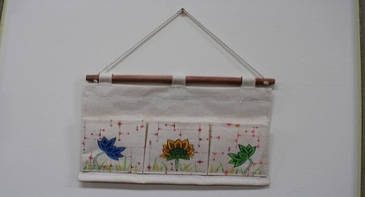 | 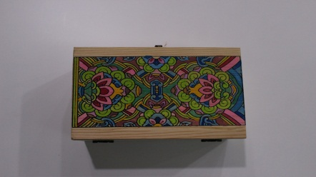
Wancho Craft | Making a phone strap | Making a necklace
Wancho Craft | 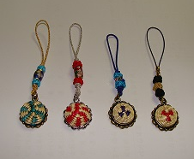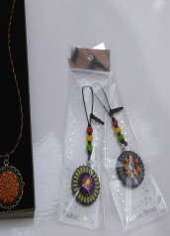 | 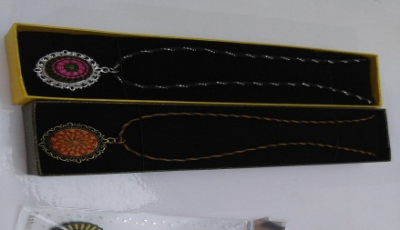
Wood Craft | Making a lucky bag | Making a mask
Wood Craft | 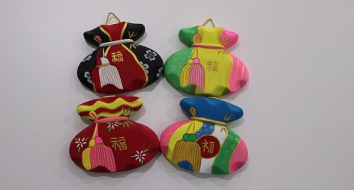 | 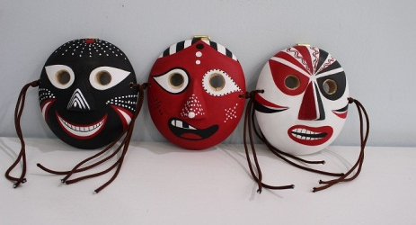
Hwagak Craft | Making a pencil holder | Making a hand mirror
Hwagak Craft | 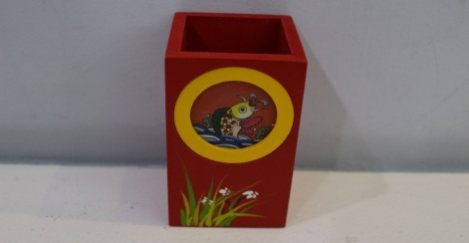 | 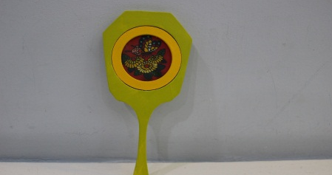
Traditional embroidery  (Tuesdays, Fridays) | Making a lucky bag | Making a naturally dyed handkerchief
Traditional embroidery  (Tuesdays, Fridays) | 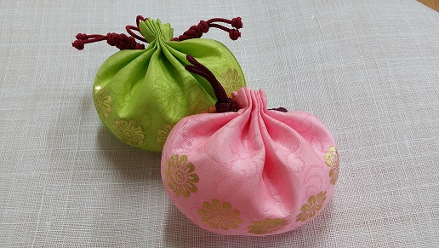 | 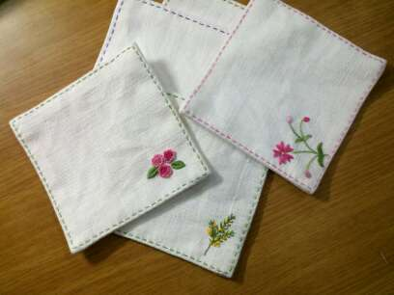
Sogeum  (Korean traditional instrument) | Learning to play Sogeum | Making a Sogeum (demonstration)
Sogeum  (Korean traditional instrument) | 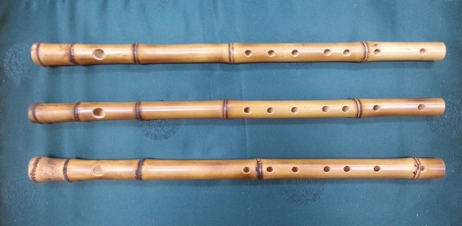 | 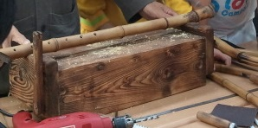
2. Application form

Division, organization,
Group name
Date & time | Month, date, year/ hour * Please specify
Reason for application
Number of participants |  | Nationality
Requested Class
Contact person | Name: / Mobile

May , 2018

City Hall Division or Organization or group name (sign)

